**Week 01-01**

**--Coding-C-Language-Features-Optional**

**Roll No:** 241801326

**Name:** Yogeetha A

**To print the statement ‘Hello, World!**’.

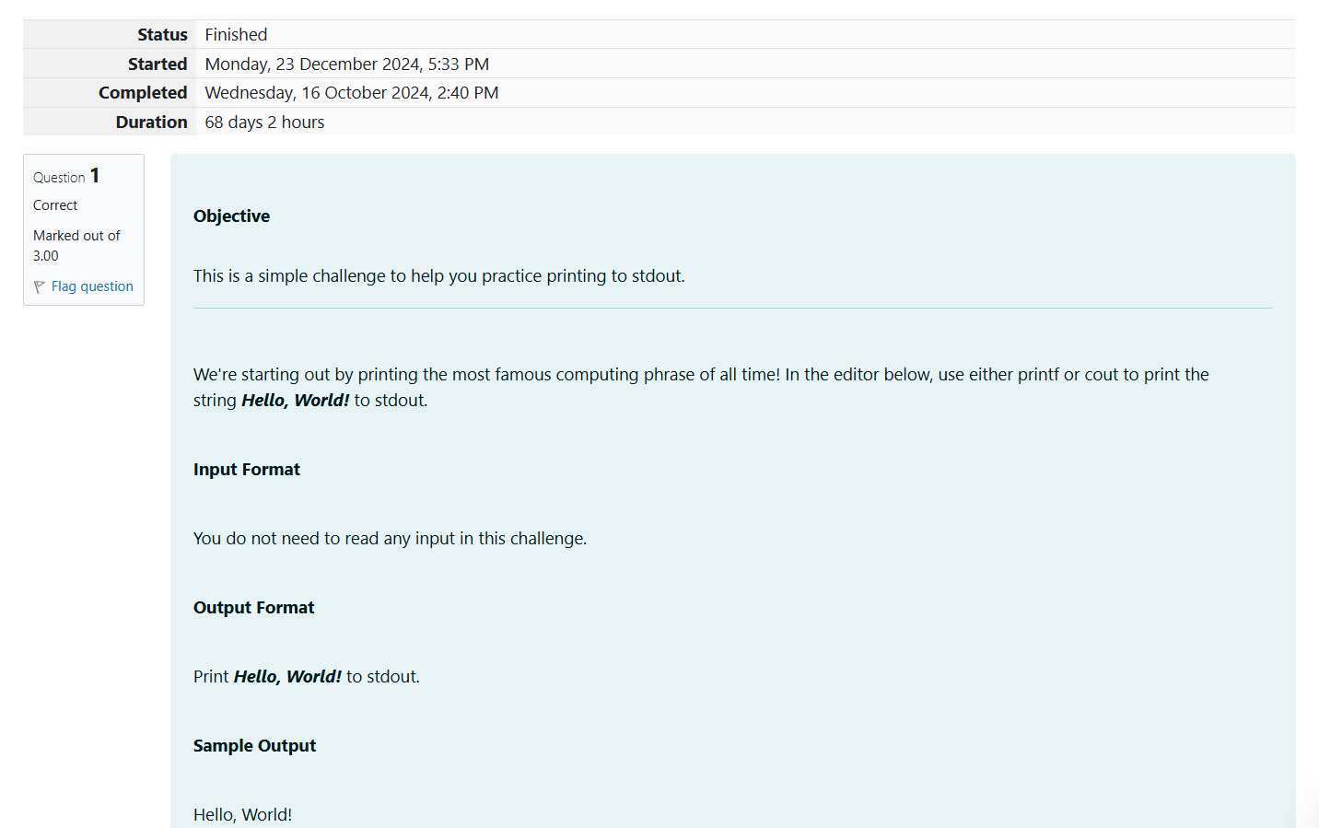

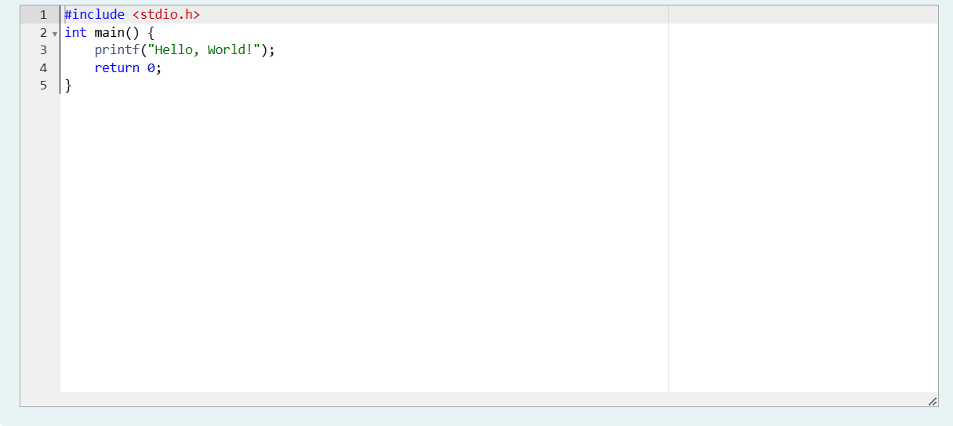

**OUTPUT:**

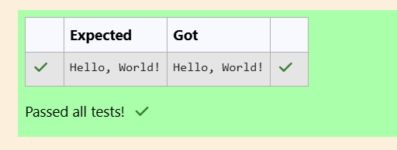

**To print the character ‘ch’.**

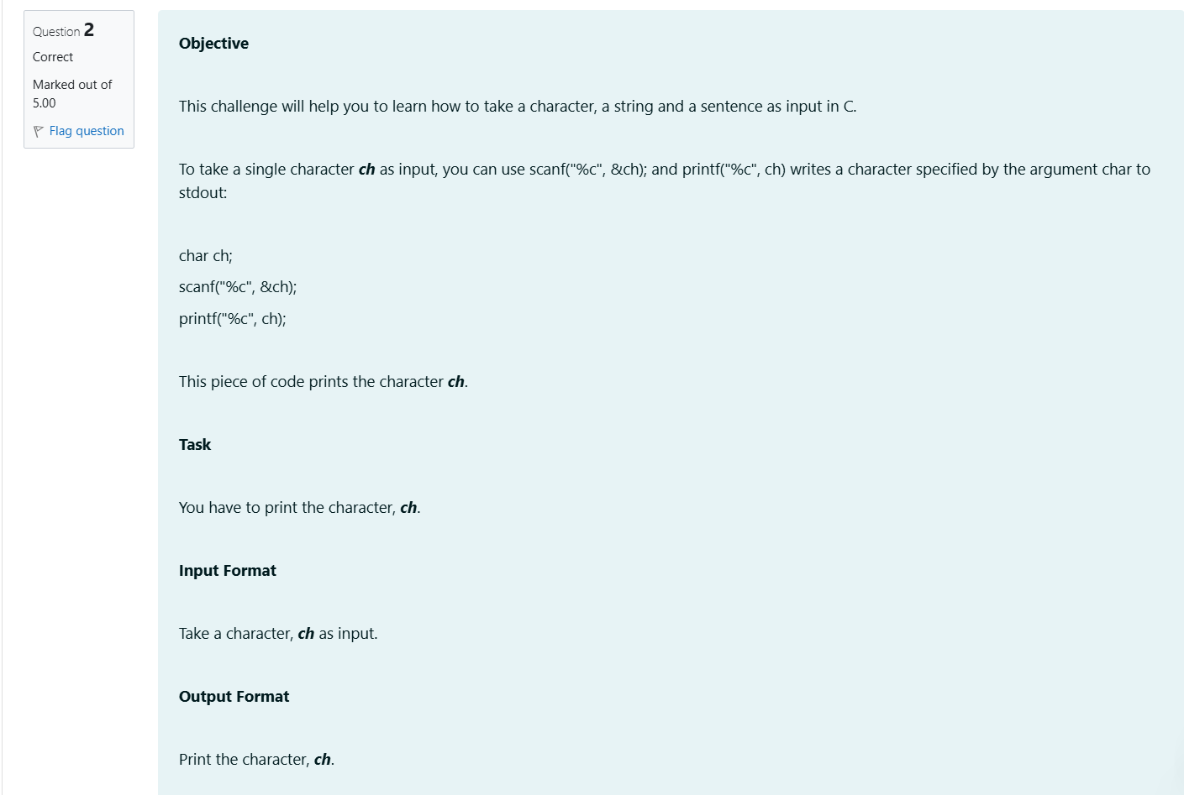

**OUTPUT:**

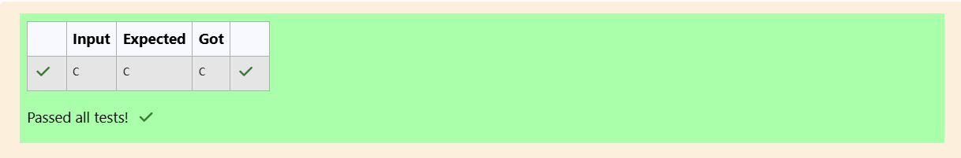

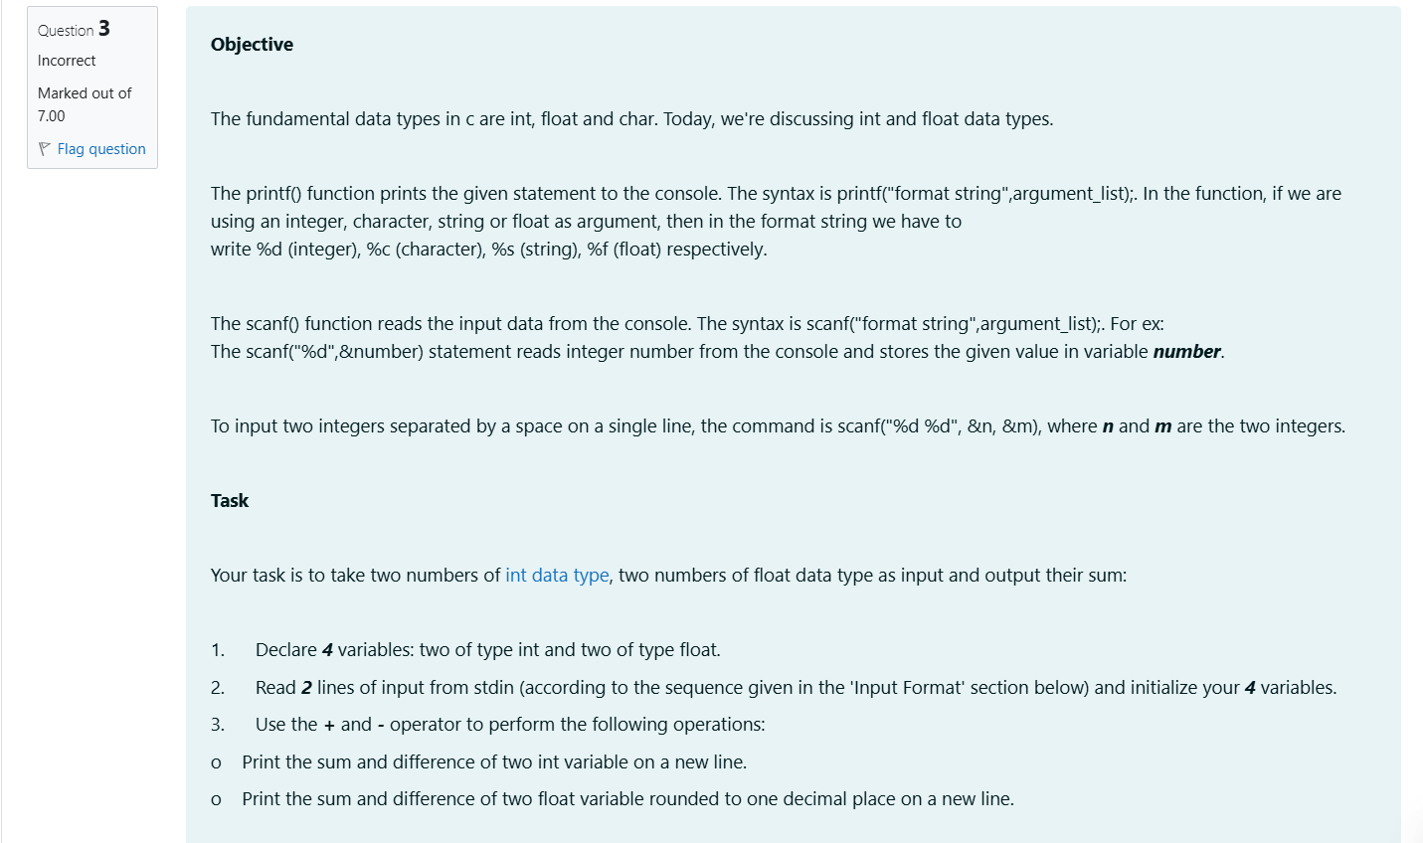

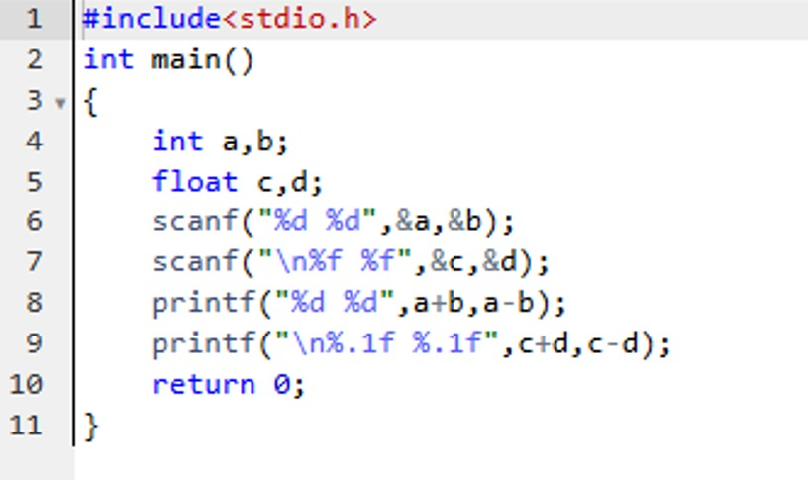

**OUTPUT:**

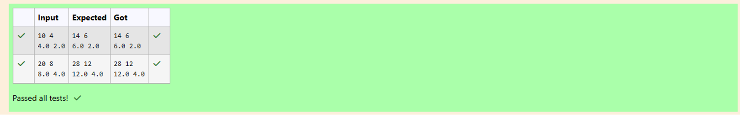

**Week 01-02**

**Roll no: 241801326**

**Name: Yogeetha A**

**Calculate the average of the given marks and print it along with the name of the student in the first line and marks in the second line.**

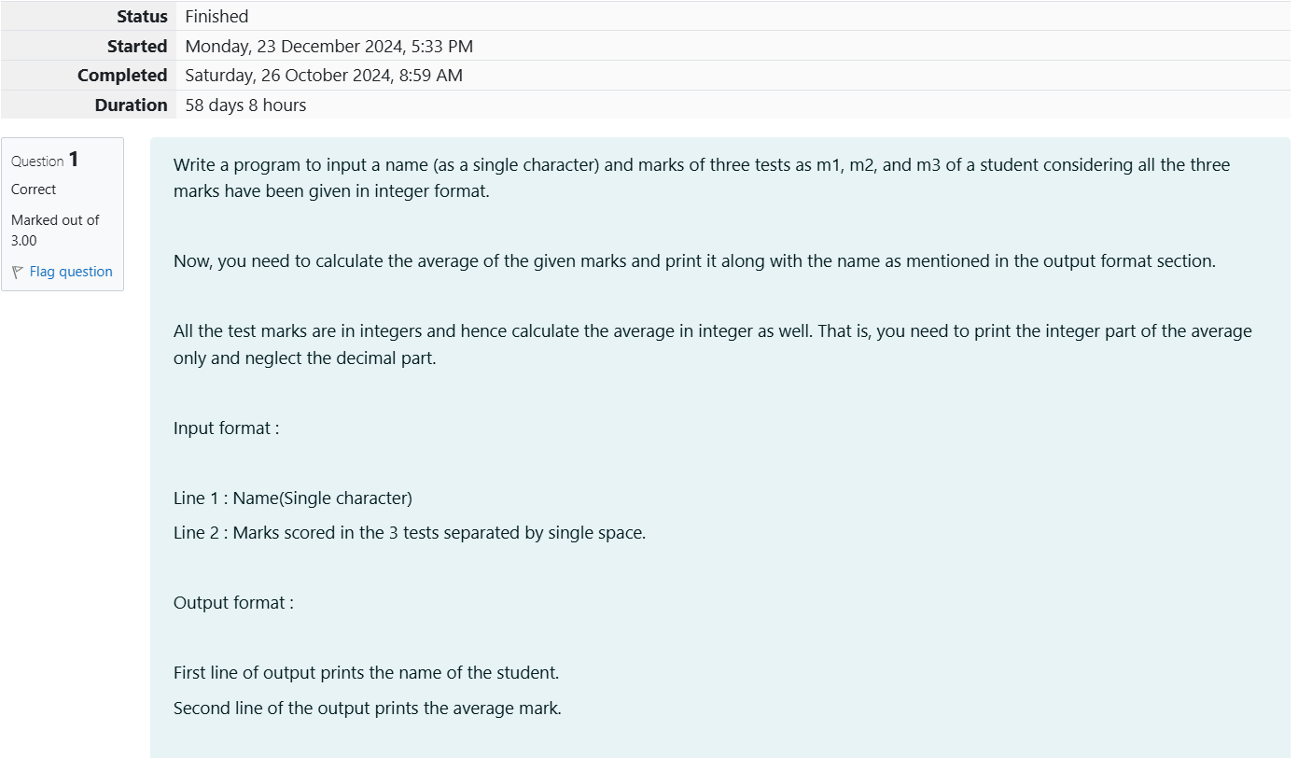

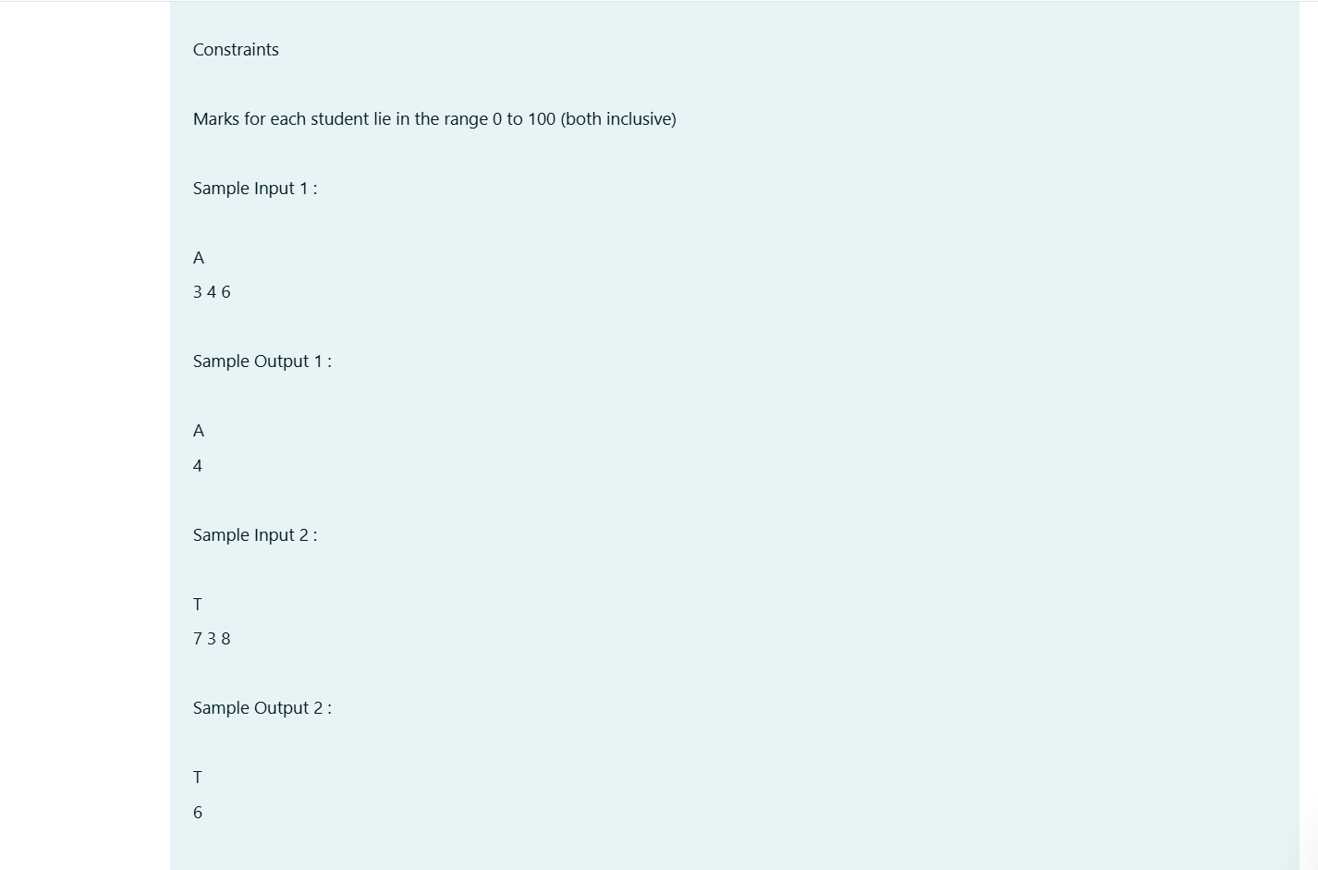

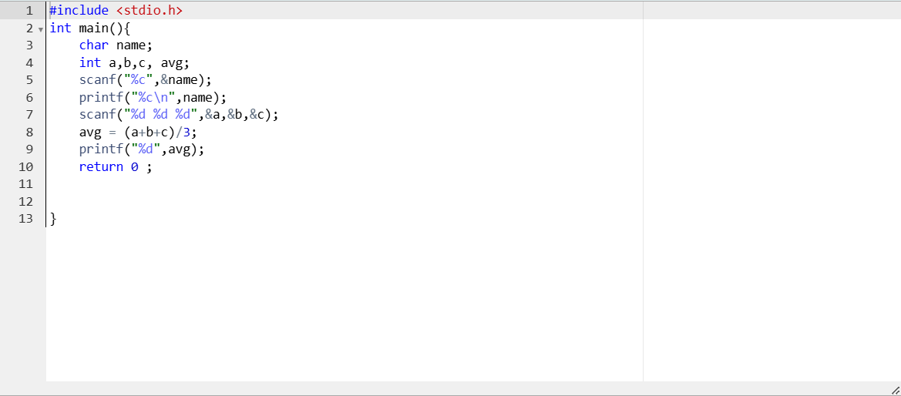

**OUTPUT:**

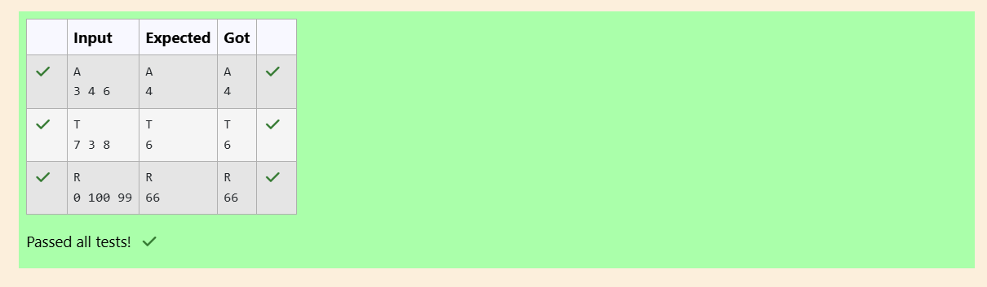

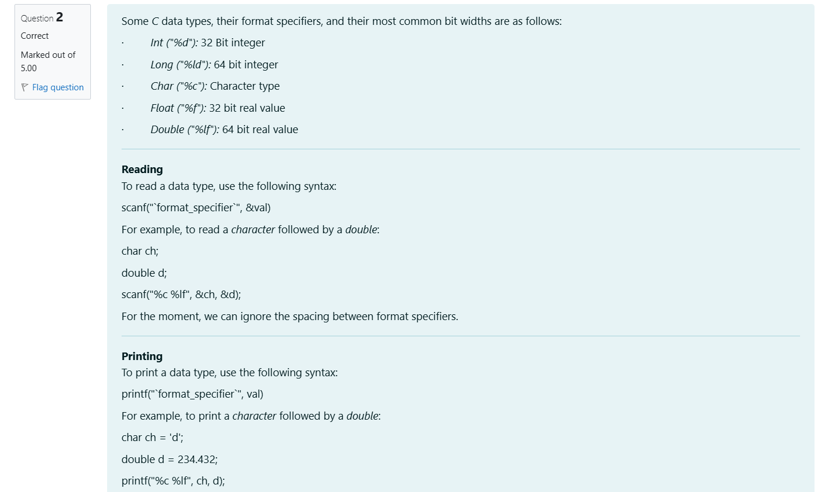

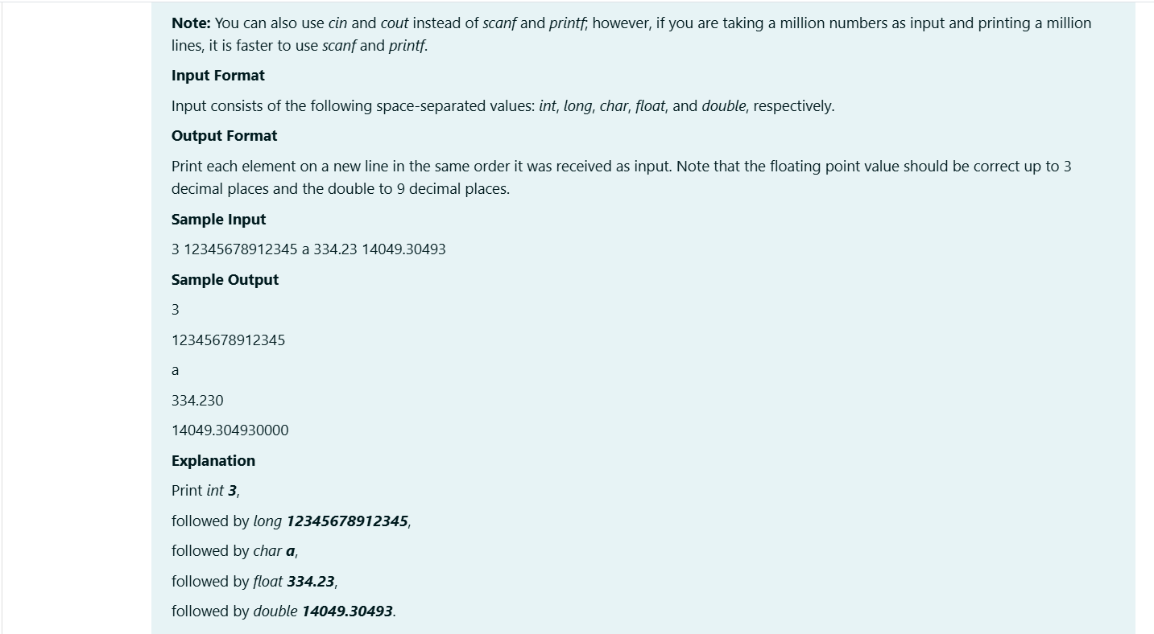

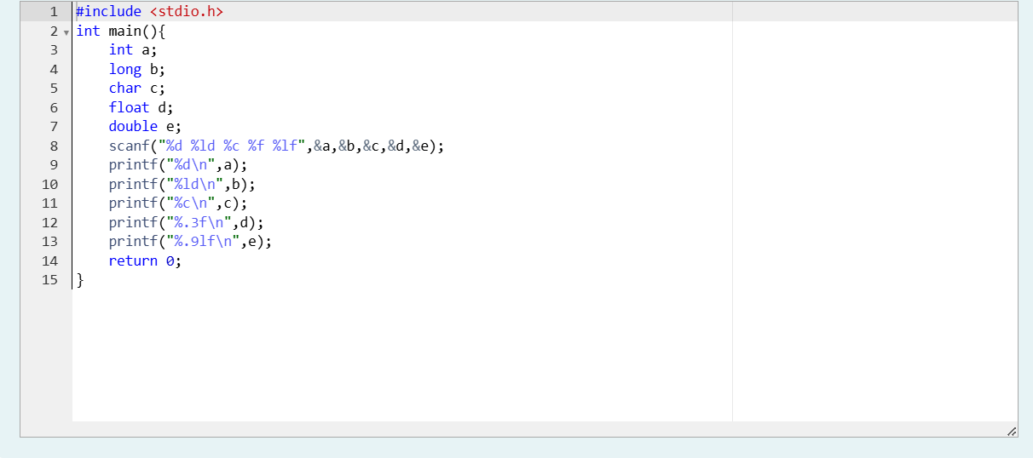

**OUTPUT:**

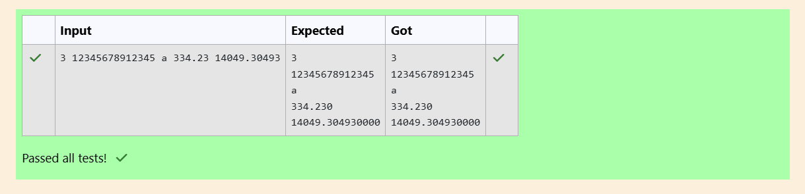

**Print the ASCII value and two adjacent characters of the given character of the given alphabet.**

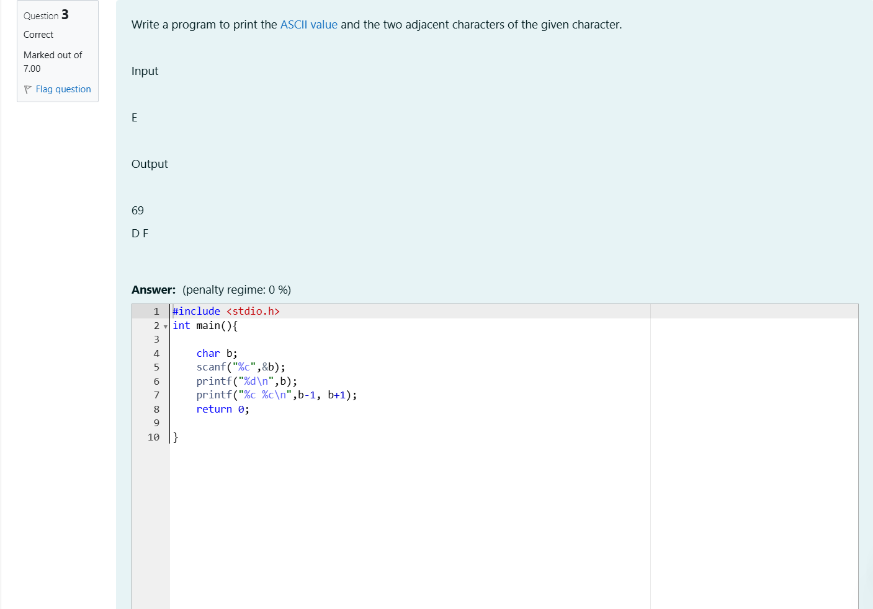

**OUTPUT:**

